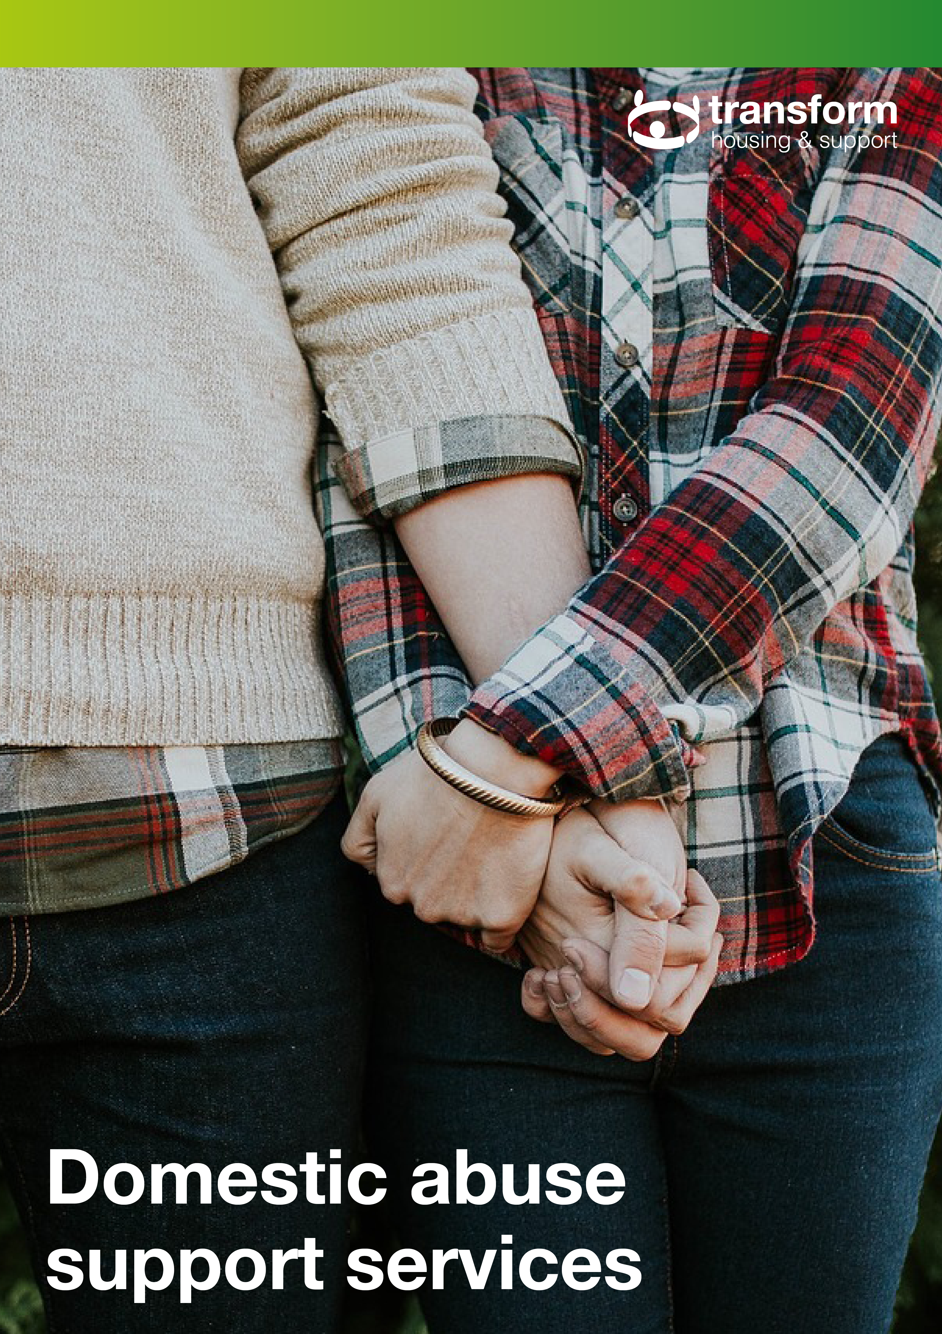

Make a Stand campaign

Transform has signed up to the Chartered Institute of Housing (CIH) appeal to tackle domestic abuse,
Make a Stand.
If in immediate danger you
should always call the Police on 999

Remember domestic violence/abuse is a crime.
Do not hesitate to report any incident to the Police

Millions of people experience domestic abuse every
year and two women are killed by their partner or
ex-partner every week. Housing organisations house
and employ millions of people across the UK and therefore house and employ many thousands of people affected by domestic abuse.

The CIH believes that the housing sector must do more on this issue. In the words of Alison Inman, ex-President of the CIH, these are “our homes, our people and this is our problem”.

Launched in June 2018, Make a Stand centres around a pledge developed in partnership with the Domestic Abuse Housing Alliance (DAHA) and Women’s Aid.

By signing up, we commit to take action and provide support for people (colleagues or clients) experiencing domestic abuse.

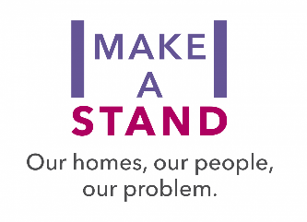
This leaflet provides information about national and local domestic abuse support services available for clients and staff.

Local support
Surrey Against Domestic Abuse
Advice, signposting and information.
Website: | www.healthysurrey.org.uk/your-health/domestic-abuse/help
Phone: | 01483 776822 | Opening hours: | 9am–9pm

East Surrey Domestic Abuse Services
Covering Reigate & Banstead, Mole Valley and Tandridge.
Website: | www.esdas.org.uk
Phone: | 01737 771350 | Email: | support@esdas.org.uk
Text: | 07860 039720 | Fax: | 01737 771284
Opening hours: | 9am – 4pm, Monday – Friday

North Surrey Outreach Service
Covering Epsom & Ewell, Elmbridge and Spelthorne. Run by Citizen’s Advice Elmbridge (West).
Website: | www.nsdas.org.uk
Phone: | 01932 260690 (Confidential answer phone available out of hours) | Email: | nsdas@caew.org.uk
Opening hours: | 9.30am-4.30pm, Monday – Friday | Fax: | 01932 221680

Your Sanctuary (North West Surrey) Outreach Services
Covering Woking, Runnymede & Surrey Heath and run by your Sanctuary.
Website: | www.yoursanctuary.org.uk
Phone: | 01483 776822 | Opening hours: | 24-hour (Online chat available)

South West Surrey Outreach Service
Covering Guildford & Waverley including Godalming, Farnham and Merrow.
Phone: | 01483 898884 (Confidential answer phone available out of hours)
Opening hours: | 9am-3pm, Monday – Friday

Surrey Family Information Service
Surrey Family Information Service (FIS) is a free impartial information and signposting service for families with children aged 0 to 25. They can help you find organisations and services that may be able to support your family including information about childcare, finances, parenting and activities in your local area.
Website: | www.surreycc.gov.uk/people-and-community/families/contact
Family information services directory: |  | familyinformationdirectory.surreycc.gov.uk/kb5/surrey/fsd/home.page
Phone: | 0300 200 1004 (9am – 5pm, Monday – Friday) |  |  | Email: | fis@surreycc.gov.uk
Text: | 07860 053 465 |  | Online enquiry form available.

Wokingham
Berkshire Women`s Aid
Refuge provides a breathing space where decisions can be made free from pressure or fear. All refuge workers are based on site.
Website: | www.berkshirewomensaid.org.uk
Wokingham Home Refuge Officer: |  | 0118 974 3799
Phone: | 0118 950 4003 | Opening hours: | 9am – 5pm on weekdays 24-hour help is also available in emergencies using the same number.

Sutton
Sutton’s Women’s Centre
Sutton Women’s Centre is run by local women for the benefit of local women, and our aim is to empower women in our community to help them achieve their full potential.
Website: | www.suttonwomenscentre.co.uk
Phone: | 020 8661 1991 | Email: | info@suttonwomen.co.uk
Opening hours: | 10am – 4pm, Monday – Friday

West Sussex/Crawley
WORTH
Support against domestic abuse.
Website: | www.worthservices.org
Phone: | 033 022 28181 | Mobile: | 07834 968539
Email: | DomesticAbuseServicesCentral@westsussex.gov.uk
Opening hours: | 9am – 5pm, Monday – Friday

Safe in Sussex
Information about refuges and support groups.
Website: | www.safeinsussex.org
Phone: | 01903 231939 | Email: | info@safeinsussex.org.uk
Opening hours: | 9.30am-4pm | Online enquiry form available.

Legal services
Rights of Women
Rights of Women is a not-for-profit organisation committed to informing, educating and empowering women on the law and their legal rights.
Website: | www.rightsofwomen.org.uk | Email: | info@row.org.uk
National family law line (inc. domestic violence)
Phone: | 020 7251 6577 | Opening hours: | Tues – Thurs 7pm – 9pm, Friday 12pm-2pm.  The line is closed on bank holidays
Criminal law (inc. sexual violence)
Phone: | 020 7251 8887 | Opening hours: | Tuesdays 7pm-9pm

National Centre for Domestic Violence (NCDV)
Free fast injunction service.
Website: | www.ncdv.org.uk | Phone: | 0207 186 8270

Community Legal Services
The CLS is part of the Legal Services Commission.
Website: | www.clsdirect.org.uk | Phone: | 0845 345 4345

Forced Marriage Protection Unit (Gov.uk)
Help to apply for a Forced Marriage Protection Order.
Website: | www.gov.uk/guidance/forced-marriage
Phone: | 020 7008 0151 | Email: | fmu@fco.gov.uk

Housing Services
All local authorities will offer help and advice to people in housing need due to domestic violence/abuse. Please check your local authority website for local help.

However, you do not need to approach your local council if you need a place in a refuge, you can contact:
National Domestic Helpline: | 0808 2000 247 (Freephone 24 Hour)

National support helplines
National Domestic Violence run in partnership between Women’s Aid and Refuge
The Helpline service provides support, information and a listening ear to women and children experiencing domestic violence and plays a pivotal role in assisting women and children to access a place of safety in a women’s refuge. The Helpline is a member of Language Line and can provide access to an interpreter for non-English speaking callers. The Helpline can also access the BT Type Talk Service. The 24 Hour National Domestic Violence Helpline will also refer male callers who require help to appropriate support groups.
Website: | www.nationaldomesticviolencehelpline.org.uk
Phone: | 0808 2000 247 | Email: | helpline@womensaid.org.uk
Opening hours: | 24/7

Women’s aid
Women’s Aid is the national charity working to end domestic abuse against women and children.
Website: | www.womensaid.org.uk | Email: | helpline@womensaid.org.uk
Phone: | 0808 2000 247 | Opening hours: | 24/7

Respect
Respect is the UK membership organisation for work with domestic violence perpetrators, male victims of domestic violence and young people’s violence in close relationships.
Perpetrators of abuse: |  | 0808 802 4040
Advice and support for men experiencing domestic violent and abuse: |  | 0808 801 0327
Opening hours: | 9am – 5pm, Monday – Friday

Men’s Advice Line
Advice and support for men experiencing domestic violence and abuse.
Website: | www.mensadviceline.org.uk
Phone: | 0808 801 0327 |  | Email: | info@mensadviceline.org.uk
Opening hours: | 9am – 5pm, Monday – Friday | Web chat is available Tuesdays and Thursday, 10am – 4pm.

The National Stalking Helpline
Practical advice and information to anyone who is currently or previously been affected by harassment or stalking.
Website: | https://www.suzylamplugh.org/Pages/Category/national-stalking-helpline
Phone: | 0808 802 0300

Hollie Guard
The Hollie Guard was developed by the Hollie Gazzard Trust which helps to reduce domestic abuse. The Hollie Guard turns your smartphone into a personal safety device. In danger? Shake your phone or tap the screen to generate an alert. Your location and audio/video evidence will automatically be sent to your emergency contacts who can take action to help you quickly.
Website: | www.hollieguard.com

Rape Crisis
Support provided by women for women and girls who have been raped or sexually abused.
Website: | www.rapecrisis.org.uk
Phone: | 0808 802 9999 | Opening hours: | Midday-2.30pm and 7pm-9.30pm daily

Safeline
Support for anyone who has been a victim of sexual abuse.
Website: | www.safeline.org.uk | Opening hours: | Visit the website for details
Helpline for men: | 0808 800 5005 | Helpline for women: | 0808 802 9999
Helpline for under 18s: | 0808 800 5007

Helplines and specialist services
Revenge Porn Helpline
A UK service supporting adults (aged 18+) who are experiencing intimate image abuse, also known as, revenge porn.
The Helpline was established in 2015 alongside the legislation which made it an offence to share intimate images or videos of someone, either on or offline, without their consent with the intention of causing distress. The Helpline is run by a small team of passionate and motivated individuals who are here and ready to help.
Website: | https://revengepornhelpline.org.uk/

Safeline
Safeline is an independent and non-discriminatory charity that provides specialist, tailored support for anyone affected by sexual abuse or rape and works to prevent the sexual exploitation of children.
Website: | https://www.safeline.org.uk/

Specialist community services
Broken Rainbow
A UK-wide specialist confidential service for lesbians, gay men, bisexual and transgender people experiencing homophobic or transphobic domestic abuse.
Website: | www.brokenrainbow.org.uk
Phone: | 0300 999 5428 | Email: | Help@brokenrainbow.org.uk
Opening hours: | Visit the website for details

Galop
Run the National LGBT+ Domestic Abuse specialist helpline
Helpline: | 0800 999 5428
Website: | galop.org.uk/domesticabuse/ | Email: | help@galop.org.uk

Imkaan
Imkaan is a women’s organisation addressing violence against black and minority women and girls
Phone: | 020 7842 8525
Website: | imkaan.org.uk/ | Email: | info@imkaan.org.uk

Karma Nirvana
Supporting victims of honour-based abuse and forced marriage.
Helpline: | 0800 5999 247
Website: | karmanirvana.org.uk/ | Email: | support@karmanirvana.org.uk

Latin American Women’s Rights Service (LAWRS)
Advocacy, information and support for migrant women provided in English, Spanish and Portuguese.
Website: | lawrs.org.uk/violencia-domesticadurante-el-aislamiento
Helpline: | 0771 928 1714 | Email: | referrals@lawrs.org.uk

Nour
Nour is an Arabic word meaning ‘light’; Nour exist as a healing light for sufferers of abuse and trauma,
and have been championing the voices of survivors of domestic abuse, sexual violence, and childhood
abuse for over 10 years. Nour specialise in supporting members of the BAME community, through a
deep understanding and expertise in working with marginalised and ‘hidden’ communities. Nour are
committed in providing services for Adults (18+).
For information or queries please email: | info@nour-dv.org.uk
For referrals (organisational or self-referrals) please email: | support@nour-dv.org.uk
Website: | https://www.nour-dv.org.uk/

Southall Black Sisters
Southall Black Sisters offer specialist support, advocacy and information to Asian and AfroCarib-bean women suffering abuse.
Phone: | 0208 571 9595 / 020 8571 0800
Website: | southallblacksisters.org.uk | Email: | info@southallblacksisters.co.uk
Maryam Centre
Provides support to women facing domestic abuse in a safe and supportive environment. Offers counselling for women.
Email: | info@maryamcentre.org.uk
Phone: | 0207 650 3022 | Website: | www.eastlondonmosque.org.uk

Stay Safe East
Stay Safe East provides specialist and holistic advocacy and support services to disabled victims and survivors of abuse.
Phone: | 0208 519 7241 | SMS/Text: | 0758 7134 122
Website: | staysafe-east.org.uk | Email: | enquiries@staysafe-east.org.uk

SignHealth
SignHealth provides domestic abuse service support for deaf people in British Sign Language (BSL).
Telephone: | 020 3947 2601 | WhatsApp or Facetime: | 07970 350366
Website: | signhealth.org.uk | Email: | da@signhealth.org.uk

Domestic Abuse Helpline for Men
This helpline is for men experiencing domestic violence.
Website: | mensadviceline.org.uk
Helpline: | 0808 801 0327 (Monday to Friday, 9am to 5pm) | Email: | info@mensadviceline.org.uk

Mankind Initiative
Mankind Initiative have a confidential helpline available for male victims of domestic abuse and domestic violence across the UK as well as their friends, family, neighbours, work colleagues and employers.
Website: | mankind.org.uk | Phone: | 01823 334244 to speak to them confidentially.

Survivors UK
Survivors UK was established as a service for male survivors. They are an inclusive service and welcome anyone who identifies as male, trans, non-binary, has identified as male in the past, or anyone who feels that we are the right fit for them.
Website: | www.survivorsuk.org | Phone: | 0203 598 3898

Other services
Chayn
An award-winning project helping women experiencing abuse through open and free multilingual resources on online safety, mental wellbeing, law and finance, all through chatbot.
Website: | chayn.co

Domestic Violence Assist
Domestic Violence Assist is available to provide immediate emergency help to victims of domestic violence.
Website: | www.dvassist.org.uk | Phone: | 0800 195 8699

National Centre for Domestic Violence
Our mission is to help people identify the early signs of domestic abuse, make decisions for a better life and to make domestic abuse socially unacceptable.
Website: | www.ncdv.org.uk | Phone: | 0800 970 2070

NSPCC (if you are worried about a child)
We’re the leading children’s charity in the UK, specialising in child protection and dedicated to protecting children today to prevent abuse tomorrow. We’re the only UK children’s charity with statutory powers, which means we can take action to safeguard children at risk of abuse.
Email: | help@nspcc.org.uk
Phone: | 0808 800 5000 (Mon-Fri, 8am to 10pm and Sat-Sun, 9am-6pm

Rights of Women
We are a women’s charity working in a number of ways to help women through the law. Our vital services aim to provide women with the legal advice and information they need to understand and use the law and their legal rights. We also work to improve the law for women and increase women’s access to justice.
Website: | rightsofwomen.org.uk | Immigration and asylum law advice: | 020 7490 7689
Family law advice: | 020 7251 6577 | Criminal law advice: | 020 7251 8887

Samaritans
Every day, Samaritans volunteers respond to around 10,000 calls for help. We’re here, day or night, for anyone who’s struggling to cope, who needs someone to listen without judgement or pressure.

Samaritans is not only for the moment of crisis; we’re taking action to prevent the crisis. We give people ways to cope and the skills to be there for others. And we encourage, promote and celebrate those moments of connection between people that can save lives.
Website: | www.samaritans.org | Phone: | 116 123

Suzy Lamplugh Trust
National Stalking Helpline
Website: | www.suzylamplugh.org | Phone: | 0808 802 0300

The Hideout
Women's Aid have created this space to help children and young people to understand domestic abuse, and how to take positive action if it's happening to you.
Website: | thehideout.org.uk

The Mix
The Mix is the UK’s leading support service for young people. We are here to help you take on any challenge you’re facing – from mental health to money, from homelessness to finding a job, from break-ups to drugs. Talk to us via our online community, on social, through our free, confidential helpline or our counselling service.
Website: | www.themix.org.uk | Phone: | 0808 808 4994

Victim Support
Victim Support is the independent charity for people affected by crime and traumatic incidents in England and Wales. Our specialist teams provide individual, independent, emotional and practical help to enable people to cope and recover from the effects of crim
Website: | www.victimsupport.org.uk | Phone: | 0808 1689 111

Respect helpline
Respect is a helpline that has been set up for anyone worried about their own behaviour. If you are worried about hurting the ones you love while staying at home, call the Respect Phoneline for support.
Website: | respectphoneline.org.uk
Phone: | 0808 802 4040 | Email: | info@respectphoneline.org.uk

